OGL SERVICE DOCUMENT

LOGIN

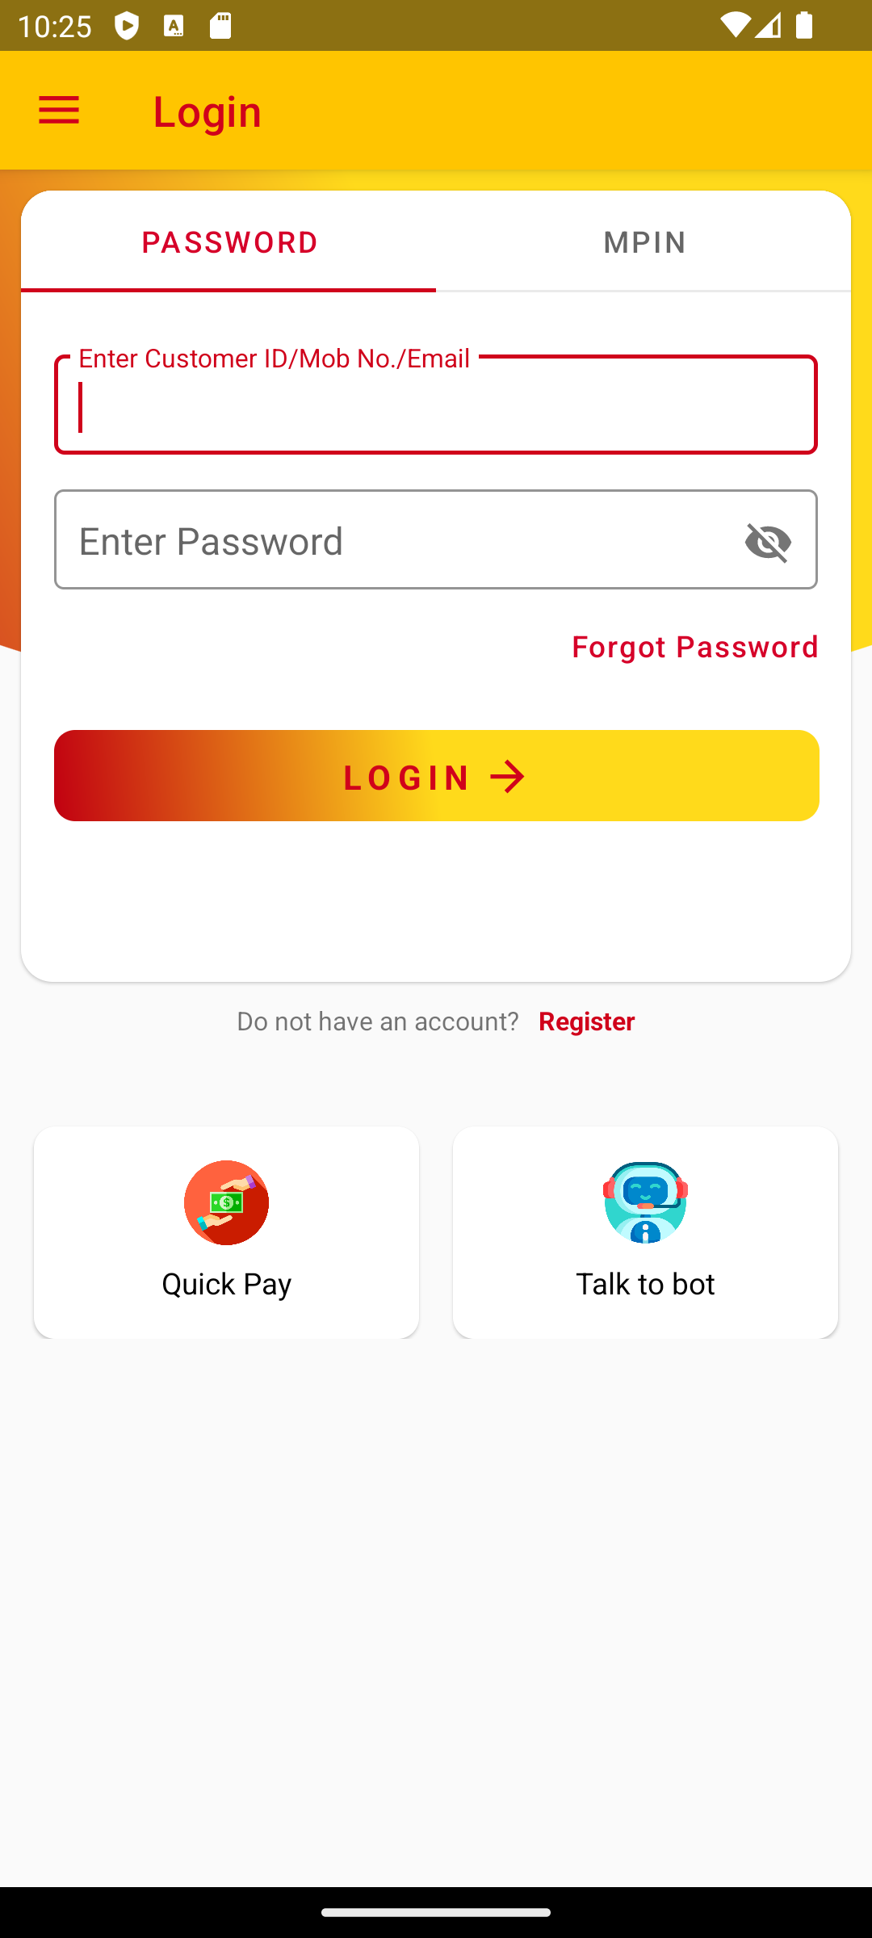
API Used:
Click Login
https://apps.asirvad.com/AsirvadGoldloan/OGLLite_MobAppService/Data_Service.asmx/mLoginEncrpt https://apps.asirvad.com/AsirvadGoldloan/OGLLite_MobAppService/Data_Service.asmx/checkOGLCustomer https://apps.asirvad.com/AsirvadGoldloan/OGLLite_MobAppService/Data_Service.asmx/GETPanStatus
Procedures
sp_online_queries
sp_online_userlogin
Tables
tbl_online_customer_details
tbl_online_user_credentials
tbl_online_custblock -- block for 30 minutes at login time
tbl_online_user_credentials
tbl_onlne_login_register
tbl_oglloginotp --- otp
Register
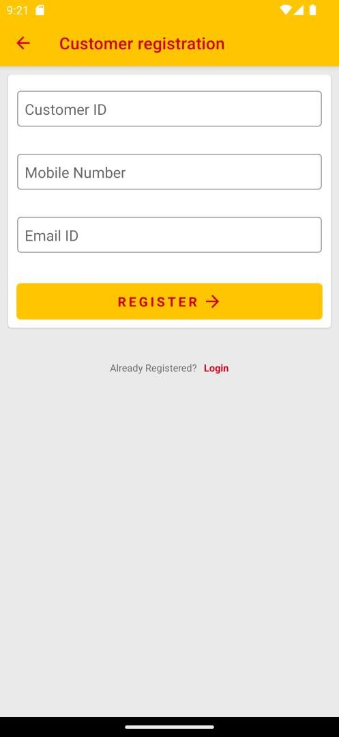
Enter Details & Submit
https://apps.asirvad.com/AsirvadGoldloan/OGLLite_MobAppService/Data_Service.asmx/mSearchCustomerandSendOTP
Enter OTP & Confirm
https://apps.asirvad.com/AsirvadGoldloan/OGLLite_MobAppService/Data_Service.asmx/otpVerification
https://apps.asirvad.com/AsirvadGoldloan/OGLLite_MobAppService/Data_Service.asmx/mRegisterCustomer
Procedure
sp_online_exsistingCusReg_1 – flag 1
Tables
CUSTOMER - phone number select
tbl_online_customer_details
tbl_online_user_credentials
TBL_ONLINE_FPASSWORD_OTPLOG - otp

Forgot Password

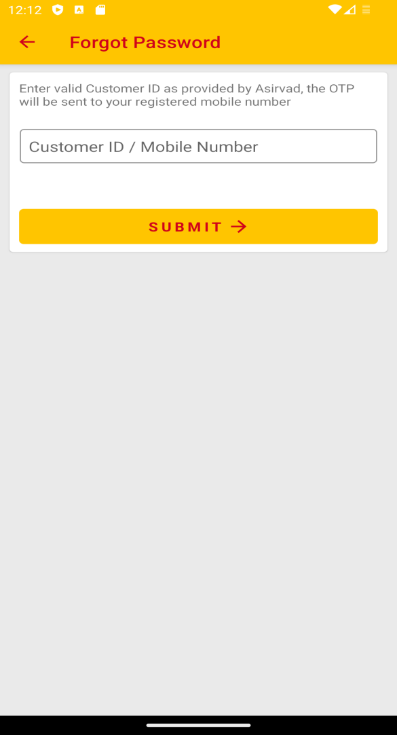

Enter customer id & Submit
https://apps.asirvad.com/AsirvadGoldloan/OGLLite_MobAppService/Data_Service.asmx/mChangePassword
Enter OTP & Verify
https://apps.asirvad.com/AsirvadGoldloan/OGLLite_MobAppService/Data_Service.asmx/otpVerificationforpchange
Enter New Password & Submit
https://apps.asirvad.com/AsirvadGoldloan/OGLLite_MobAppService/Data_Service.asmx/mUpdatePassword
Procedure
sp_online_userpasschg
Tables
tbl_online_customer_details
tbl_online_user_credentials
TBL_ONLINE_FPASSWORD_OTPLOG - otp

Dashboard
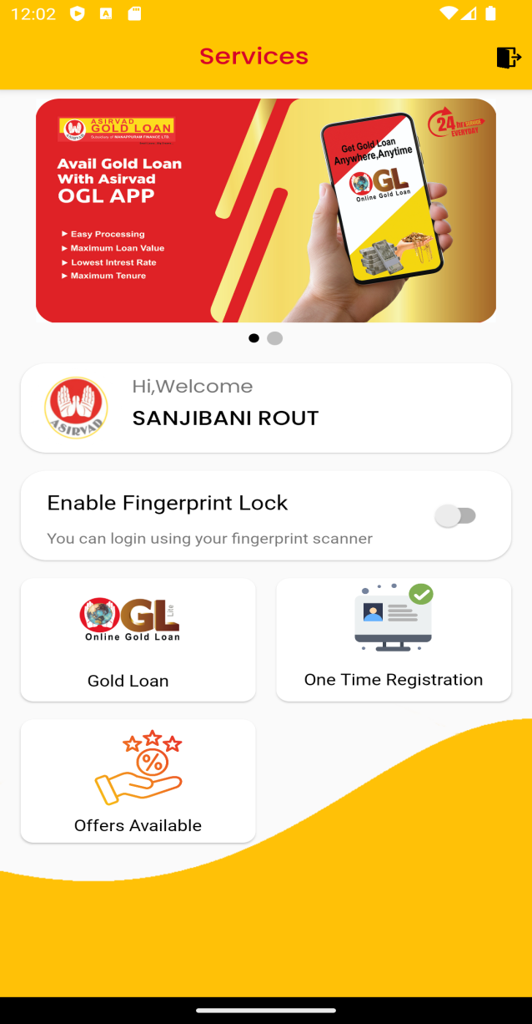

One Time Registration
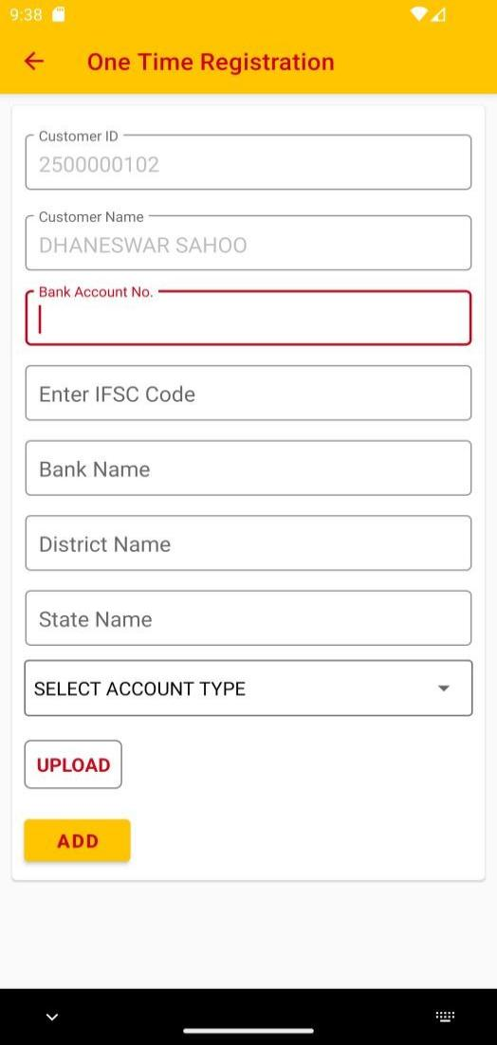

API Used:
While loading Register Page
https://apps.asirvad.com/AsirvadGoldloan/OGLLite_MobAppService/Data_Service.asmx/GetAccType
While Enter IFSC Code
https://apps.asirvad.com/AsirvadGoldloan/customer_public/api/banks/searchifsc
Submit
https://apps.asirvad.com/AsirvadGoldloan/OGLLite_MobAppService/Data_Service.asmx/oneTimeSendOTP
Enter OTP and confirm
https://apps.asirvad.com/AsirvadGoldloan/OGLLite_MobAppService/Data_Service.asmx/OnetimeOTPVerification
https://apps.asirvad.com/Asirvadgoldloan/mfpublickycapi/api/bank https://apps.asirvad.com/AsirvadGoldloan/customer_public/api/banks/banks
https://apps.asirvad.com/Asirvadgoldloan/customer_public/api/Photo/AddBankOgl
https://apps.asirvad.com/AsirvadGoldloan/los_public/api/members/addimages
https://apps.asirvad.com/AsirvadGoldloan/OGLLite_MobAppService/Data_Service.asmx/otr_customer_bank_details_submit

Procedure
Sp_online_queries
Tables
CUSTOMER_BANK_PASSBOOK t
customer_bank_passbook_his t
TBL_ADD_NEFT_CUSTOMER t
aml_customer.tbl_customer_images t
aml_accounts.NEFT_CUSTOMER t
tbl_online_gl_cust_mst t--- online customer verification
aml_customer.tbl_customer_bank_details t -- bank details status 1
aml_customer.tbl_customer t
tbl_online_customer_details t
ONLINE_CUSTOMER_AGREEMENT t
Penny Drop (digital)
API Used:
https://amfluat.asirvad.com/AsirvadGoldloan/OGLLite_MobAppService/Data_Service.asmx/CustomerName_Check
https://amfluat.asirvad.com/AsirvadGoldloan/OGLLite_MobAppService/Data_Service.asmx/OnetimesendOTP
https://amfluat.asirvad.com/AsirvadGoldloan/OGLLite_MobAppService/Data_Service.asmx/OnetimeOTPVerification
https://amfluat.macom.in/Asirvadgoldloan/mfpublickycapi/api/bank
https://amfluat.macom.in/AsirvadGoldloan/customer_public/api/banks/banks
https://amfluat.macom.in/AsirvadGoldloan/customer_public/api/Photo/AddBankOgl
https://amfluat.macom.in/AsirvadGoldloan/los_public/api/members/addimages
https://amfluat.macom.in/AsirvadGoldloan/OGLLite_MobAppService/Data_Service.asmx/otr_customer_bank_details_submit
https://amfluat.macom.in/AsirvadGoldloan/OGLLite_MobAppService/Data_Service.asmx?op=Bank_Verification_BH
https://amfluat.macom.in/AsirvadGoldloan/OGLLite_MobAppService/Data_Service.asmx/penny_customer_bank_details_submit
Procedure
Sp_online_queries
Tables
CUSTOMER_BANK_PASSBOOK t
customer_bank_passbook_his t
TBL_ADD_NEFT_CUSTOMER t
aml_customer.tbl_customer_images t
aml_accounts.NEFT_CUSTOMER t
tbl_online_gl_cust_mst t--- online customer verification
aml_customer.tbl_customer_bank_details t -- bank details status 1
aml_customer.tbl_customer t
tbl_online_customer_details t
ONLINE_CUSTOMER_AGREEMENT t
TBL_OGL_PENNYCUST_UPDATE_DTL – new table with bank added status and update 2 times
TBL_OGL_PENNYDROP_CUSTOMER_DTL

OGL
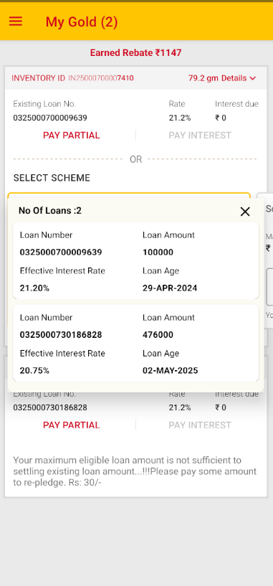
API Used:
https://apps.asirvad.com/AsirvadGoldloan/OGLLite_MobAppService/Data_Service.asmx/GetPledeges https://apps.asirvad.com/AsirvadGoldloan/OGLLite_MobAppService/Data_Service.asmx/GetPledgeDetailsOnline https://apps.asirvad.com/AsirvadGoldloan//OGLLite_MobAppService/Data_Service.asmx/GetSchemeDetails
https://apps.asirvad.com/AsirvadGoldloan/OGLLite_MobAppService/Data_Service.asmx/check_email_update
Procedures
Pledge_ogl
Sp_online_home – flag 3
Sp_online_queries -59 (for item details)
Sp_online_queries -57 (scheme details)
Pledge_new_schemes_controls_o
Tables
Tbl_full_deduction,
Gold_dtl
Update on tbl_online_ctran_entries – DISB_STR column (scheme string)

While Click gm details dropdown
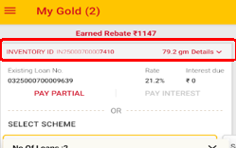
https://apps.asirvad.com/AsirvadGoldloan/OGLLite_MobAppService/Data_Service.asmx/mLoanDetails
https://apps.asirvad.com/AsirvadGoldloan/OGLLite_MobAppService/Data_Service.asmx/GetItemDetails
While Click Interest Rate
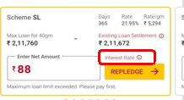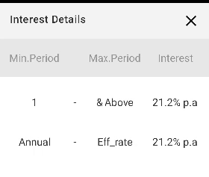
https://apps.asirvad.com/AsirvadGoldloan/OGLLite_MobAppService/Data_Service.asmx/GetInterestSlab
Procedures
sp_online_queries flag 59

PAYMENT (PART AND INTEREST)
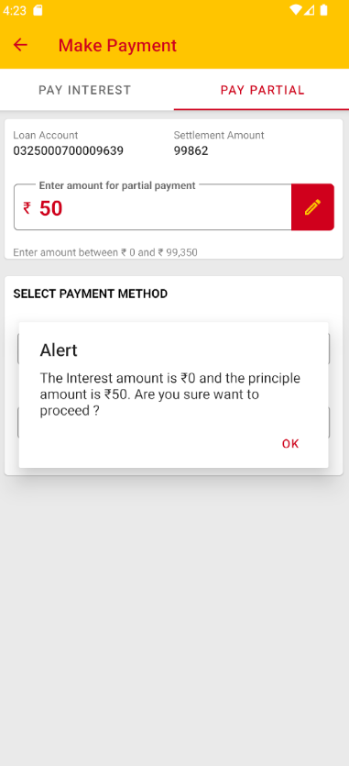
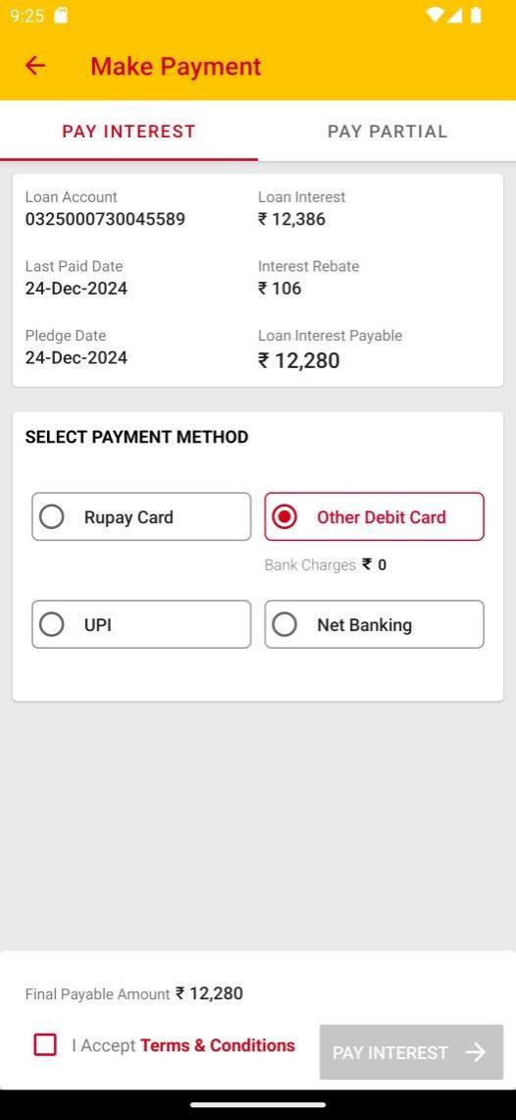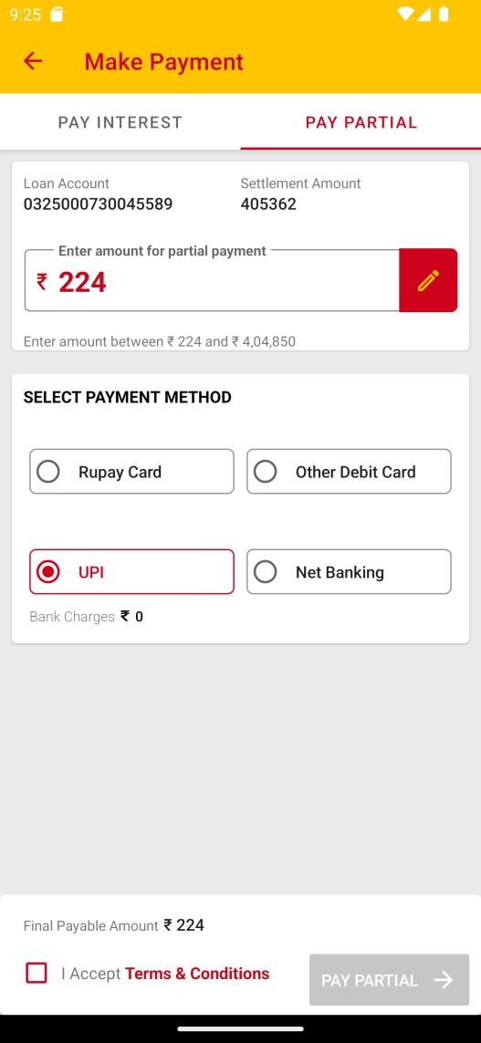
Click Pay Partial
https://apps.asirvad.com/AsirvadGoldloan/OGLLite_MobAppService/Data_Service.asmx/mPledgeDetails
Click Pay Interest
https://apps.asirvad.com/AsirvadGoldloan/OGLLite_MobAppService/Data_Service.asmx/mPledgeDetails
https://apps.asirvad.com/AsirvadGoldloan/OGLLite_MobAppService/Data_Service.asmx/mLoanDetails
Procedure
Sp_online_home key 2 will call (pledge’s interest rebate waiver all charges will get)
Click Edit in Pay partial
https://apps.asirvad.com/AsirvadGoldloan/OGLLite_MobAppService/Data_Service.asmx/mPartPayAmountUpdate
update part pay amt in tbl_online_ctran entries

Select Payment Method
https://apps.asirvad.com/AsirvadGoldloan/OGLLite_MobAppService/Data_Service.asmx/mGetServiceCharge
Procedure
sp_online_queries flag 30 for calculate bank service charge based on paymode
Click Confirm (Redirect to Payu Payment Gateway)
https://apps.asirvad.com/AsirvadGoldloan/OGLLite_MobAppService/Data_Service.asmx/payuinputdata
generate hash key call payu gateway
On Success Response from payu
https://apps.asirvad.com/AsirvadGoldloan/OGLLite_MobAppService/Data_Service.asmx/online_payment_receipt
https://apps.asirvad.com/AsirvadGoldloan/OGLLite_MobAppService/Data_Service.asmx/mFinalCheck
https://apps.asirvad.com/AsirvadGoldloan/OGLLite_MobAppService/Data_Service.asmx/mTransaction
Procedure
sp_online_transactions- flag 2
pledge_closing_entries_online
payment entries on to transaction tables
Tables
select t.*, t.rowid from aml_gloan.TBL_ONLINE_CTRAN_ENTRIES t
where t.col_status=2
and t.col_pay_mode=2
and to_date(t.col_tra_date)=to_date(sysdate)
order by t.col_tra_date desc;
select t.*, t.rowid from aml_gloan.pledge_status t
where pledge_no = '0342910700000864';
select t.*, t.rowid from aml_gloan.pledge_status t
where pledge_no = '0342910730000157';
select t.*, t.rowid from aml_gloan.cus_tran t
where pledge_no = '0329620700001732';

select nvl(sum(decode(type, 'D', amount, amount * -1)), 0)
from aml_gloan.cus_tran t
where t.pledge_no='0329620700001732';
select t.status from aml_gloan.tbl_gln_inventory_master t
where t.plgno = '0329620700001732';

select t.*,t.rowid from aml_gloan.transaction_detail t
where t.REF_ID='0329620700001732';
select t.*,t.rowid from aml_accounts.subsidary_transaction t
where t.descr like '%0329620700001732%';
On Failed Response from payu
https://apps.asirvad.com/AsirvadGoldloan/OGLLite_MobAppService/Data_Service.asmx/MFailedTransaction
update failed status 3 on tbl_online_ctran_entries
https://apps.asirvad.com/AsirvadGoldloan/OGLLite_MobAppService/Data_Service.asmx/online_payment_receipt
send mail with payment reciept

Repledge

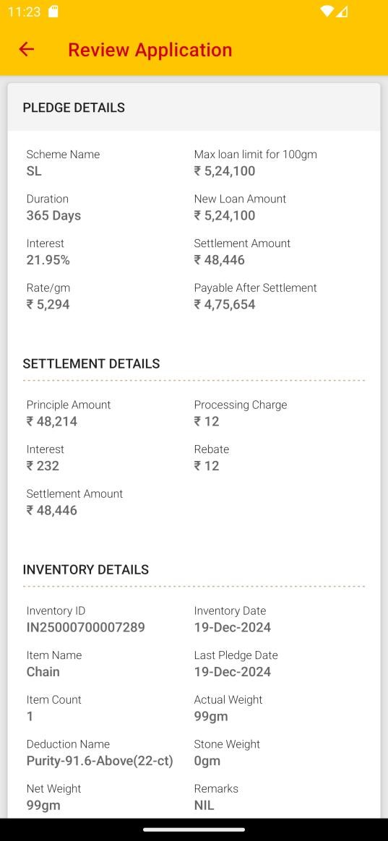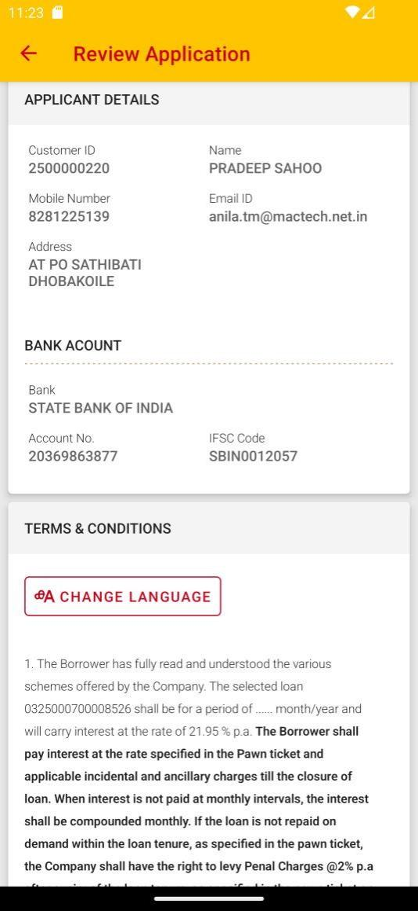

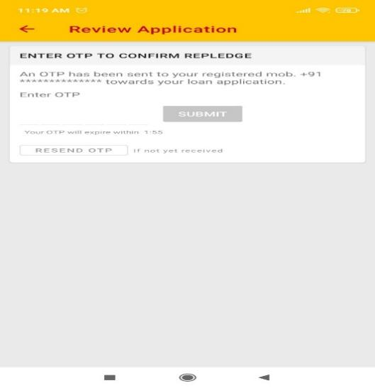

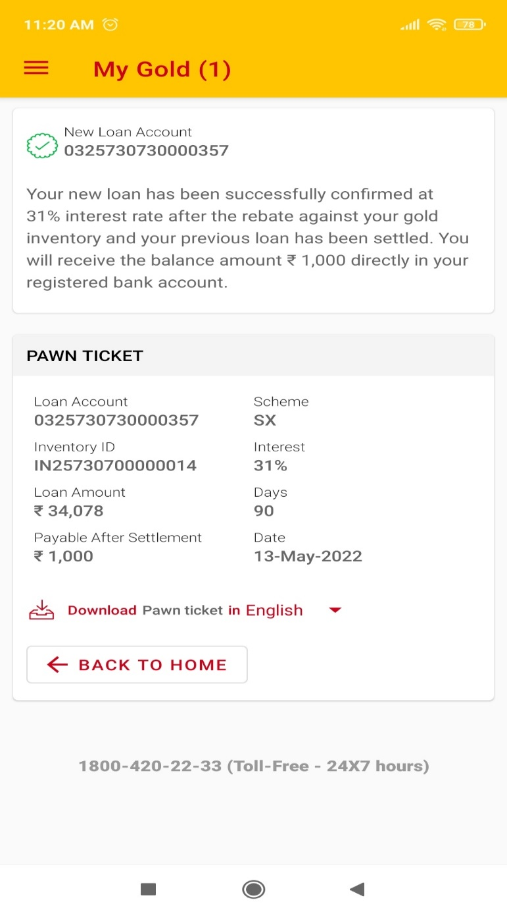
https://apps.asirvad.com/AsirvadGoldloan/OGLLite_MobAppService/Data_Service.asmx/GetSelectedSchemeDetails
Click repledge Button list purpose
https://apps.asirvad.com/AsirvadGoldloan/OGLLite_MobAppService/Data_Service.asmx/get_purpose
After Select purpose
https://apps.asirvad.com/AsirvadGoldloan/OGLLite_MobAppService/Data_Service.asmx/get_declaration_for_excess_portion
https://apps.asirvad.com/AsirvadGoldloan/OGLLite_MobAppService/Data_Service.asmx/mCustomerProfile
https://apps.asirvad.com/AsirvadGoldloan/OGLLite_MobAppService/Data_Service.asmx/GetkfsDetails
https://apps.asirvad.com/AsirvadGoldloan/OGLLite_MobAppService/Data_Service.asmx/mLoanDetails
https://apps.asirvad.com/AsirvadGoldloan/OGLLite_MobAppService/Data_Service.asmx/GetCusAccntDetails
https://apps.asirvad.com/AsirvadGoldloan/OGLLite_MobAppService/Data_Service.asmx/GetItemDetails
https://apps.asirvad.com/AsirvadGoldloan/OGLLite_MobAppService/Data_Service.asmx/GetTermsandConditionsDetails
On Submit
https://apps.asirvad.com/AsirvadGoldloan/OGLLite_MobAppService/Data_Service.asmx/GetRequiredAmtDetails
https://apps.asirvad.com/AsirvadGoldloan/OGLLite_MobAppService/Data_Service.asmx/OglConfirmation
Enter OTP & SUBMIT
https://apps.asirvad.com/AsirvadGoldloan/OGLLite_MobAppService/Data_Service.asmx/GetNewloanDetails -
Download Pawn Ticket Clicks
https://apps.asirvad.com/AsirvadGoldloan/OGLLite_MobAppService/Data_Service.asmx/GetPawnTicket
Enter OTP & SUBMIT
https://apps.asirvad.com/AsirvadGoldloan/OGLLite_MobAppService/Data_Service.asmx/verifyOTPforPawnTicket

My Profile
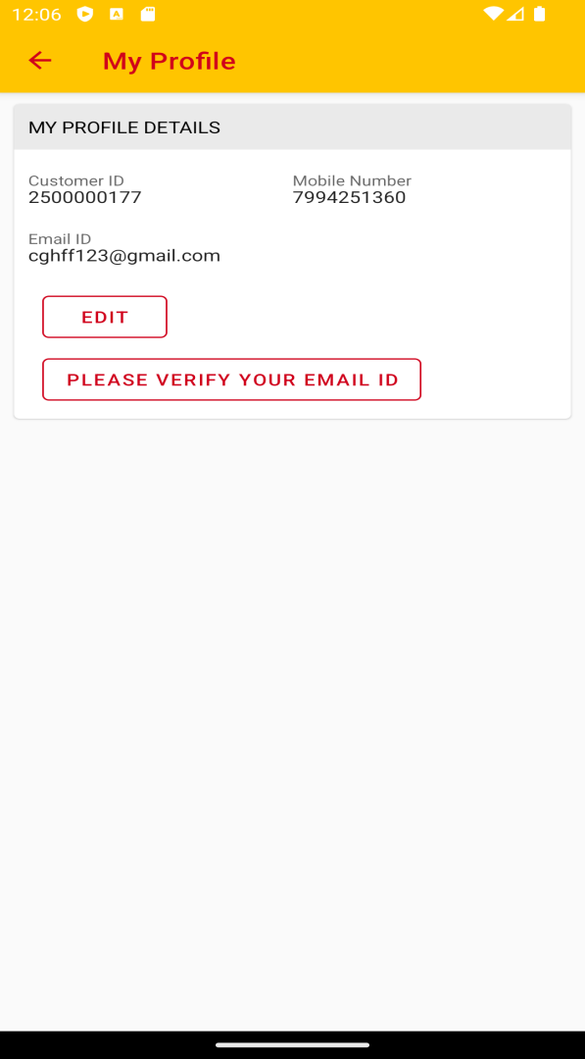
Click my profile
https://apps.asirvad.com/AsirvadGoldloan/OGLLite_MobAppService/Data_Service.asmx/mCustomerProfile
When Click Edit and save
https://apps.asirvad.com/AsirvadGoldloan/OGLLite_MobAppService/Data_Service.asmx/SendOtpmail
Enter OTP & SUMBIT
https://apps.asirvad.com/AsirvadGoldloan/OGLLite_MobAppService/Data_Service.asmx/verifyOTPformail
Click Verify Your Email
https://apps.asirvad.com/AsirvadGoldloan/OGLLite_MobAppService/Data_Service.asmx/SendOtpmailverification
Enter OTP & Submit
https://apps.asirvad.com/AsirvadGoldloan/OGLLite_MobAppService/Data_Service.asmx/verifyOTPformailverification
Pledge History
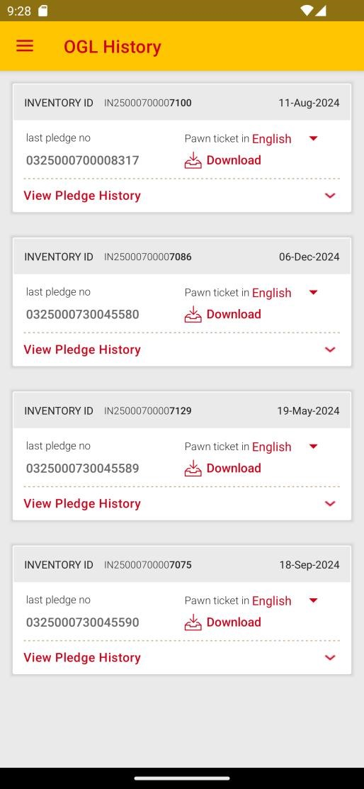

https://apps.asirvad.com/AsirvadGoldloan/OGLLite_MobAppService/Data_Service.asmx/GetPledeges
Click View Pledge History & Enter Dates
https://apps.asirvad.com/AsirvadGoldloan/OGLLite_MobAppService/Data_Service.asmx/GetOglHistory

Click Download pawn ticket
https://apps.asirvad.com/AsirvadGoldloan/OGLLite_MobAppService/Data_Service.asmx/GetPawnTicket
Enter OTP & Submit
https://apps.asirvad.com/AsirvadGoldloan/OGLLite_MobAppService/Data_Service.asmx/verifyOTPforPawnTicket

Transaction History

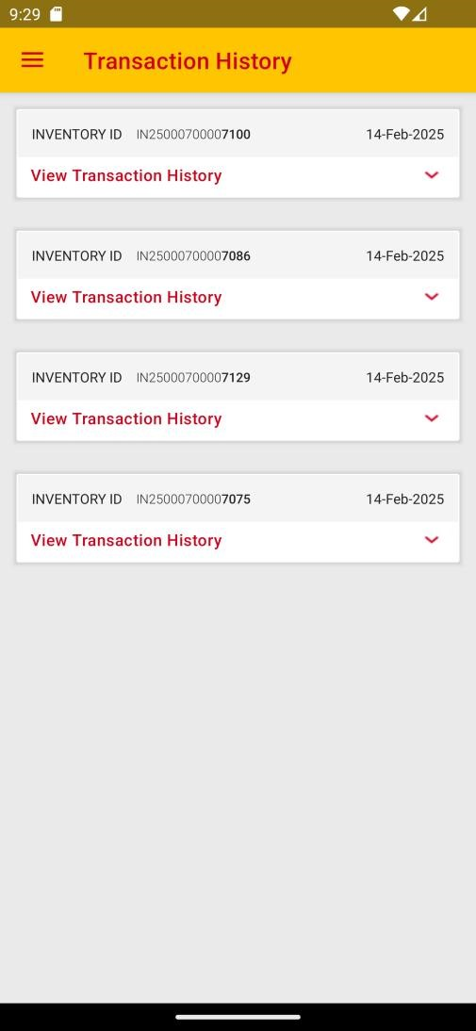

Click Transaction History
https://apps.asirvad.com/AsirvadGoldloan/OGLLite_MobAppService/Data_Service.asmx/GetPledeges
Click view Transaction History
https://apps.asirvad.com/AsirvadGoldloan/OGLLite_MobAppService/Data_Service.asmx/GetOnlpaymentHistory

KFS Download
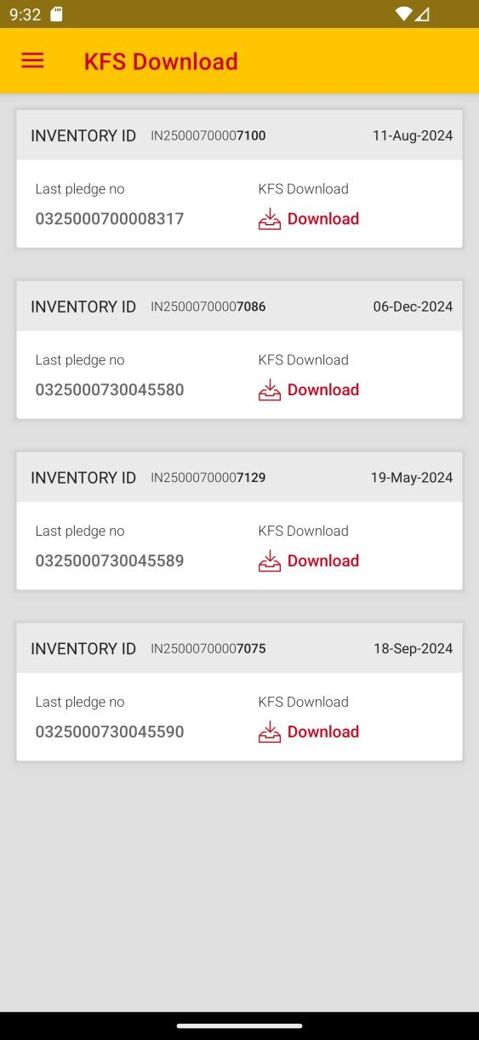
KFS Download
https://apps.asirvad.com/AsirvadGoldloan/OGLLite_MobAppService/Data_Service.asmx/GetPledeges
Click Download
https://apps.asirvad.com/AsirvadGoldloan/OGLLite_MobAppService/Data_Service.asmx/SendOtpKfs
Enter OTP & Submit
https://apps.asirvad.com/AsirvadGoldloan/OGLLite_MobAppService/Data_Service.asmx/verifyOTPforkfs

Change Password

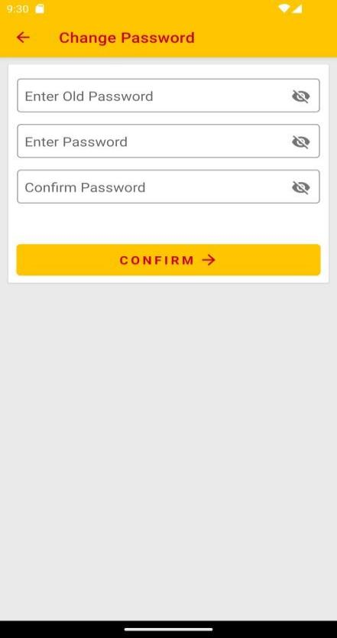

https://apps.asirvad.com/AsirvadGoldloan/OGLLite_MobAppService/Data_Service.asmx/mUpdatePassword_change

RESET MPIN

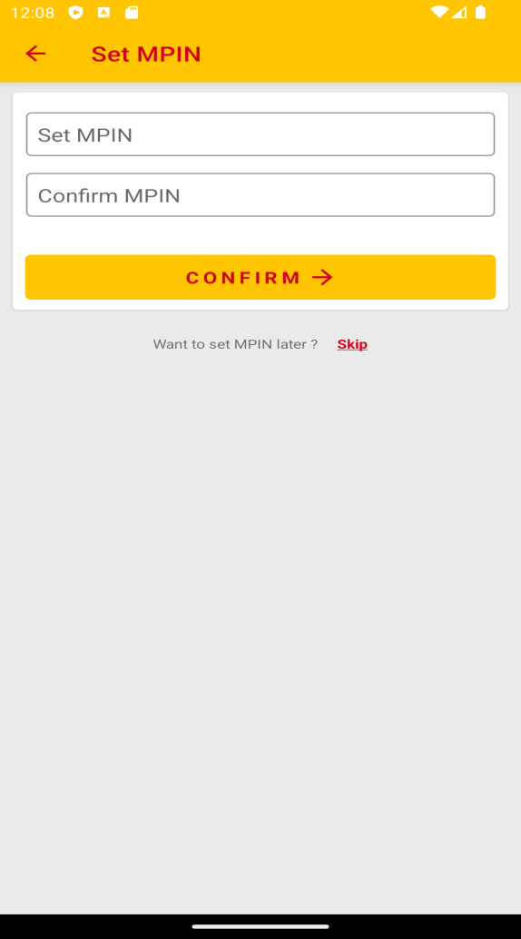
https://apps.asirvad.com/AsirvadGoldloan/OGLLite_MobAppService/Data_Service.asmx/mcustomerMPINrequest
Enter OTP & Submit
https://apps.asirvad.com/AsirvadGoldloan/OGLLite_MobAppService/Data_Service.asmx/mcustomerMPINotpVerification
https://apps.asirvad.com/AsirvadGoldloan/OGLLite_MobAppService/Data_Service.asmx/mcustomerMPINgeneration

CHANGE MPIN
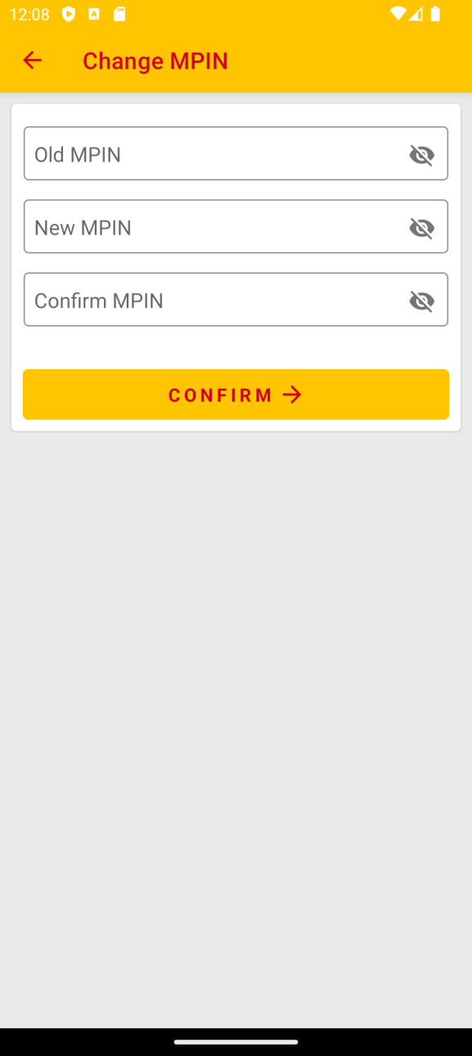

https://apps.asirvad.com/AsirvadGoldloan/OGLLite_MobAppService/Data_Service.asmx/mcustomerChangeMPIN

LOAN CALCULATOR

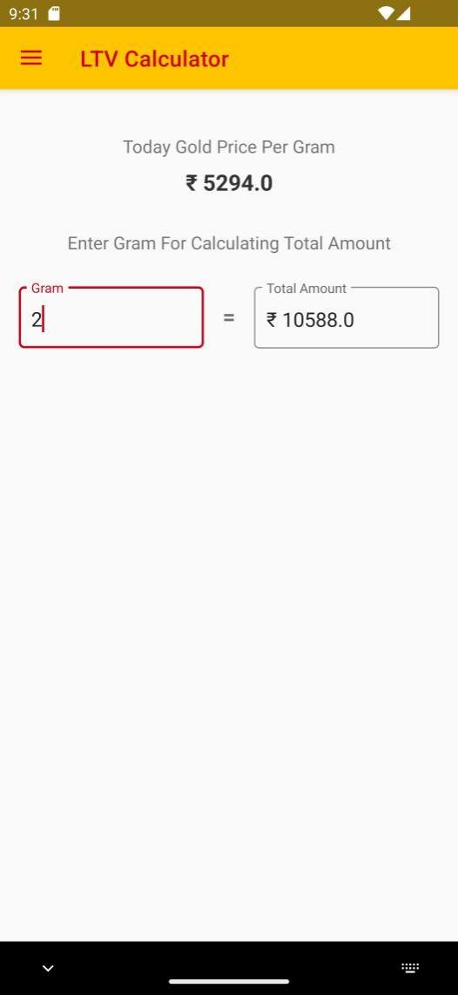

To display Today Gold Price
https://apps.asirvad.com/AsirvadGoldloan/OGLLite_MobAppService/Data_Service.asmx/ogl_Daily_ltv

OPTOUT

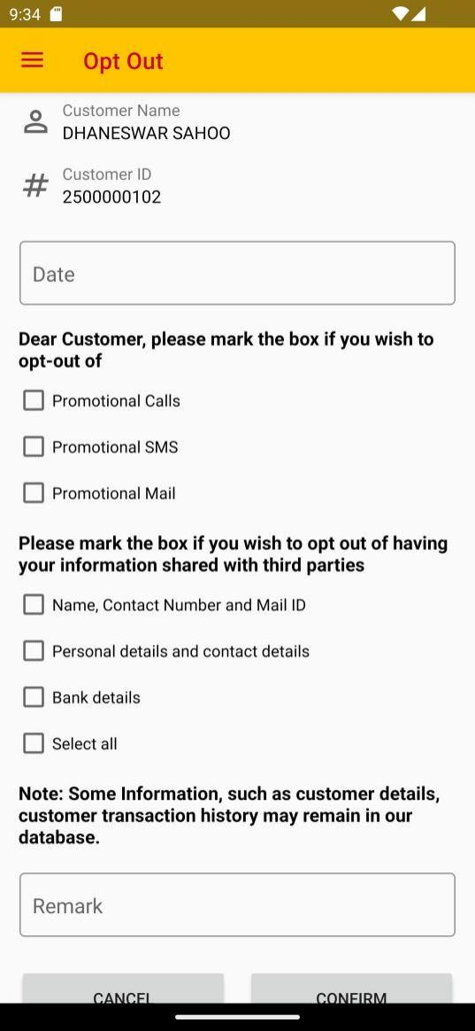

https://apps.asirvad.com/AsirvadGoldloan/OGLLite_MobAppService/Data_Service.asmx/opted_customer
Click Confirm
https://apps.asirvad.com/AsirvadGoldloan/OGLLite_MobAppService/Data_Service.asmx/add_opt_option

FEEDBACK
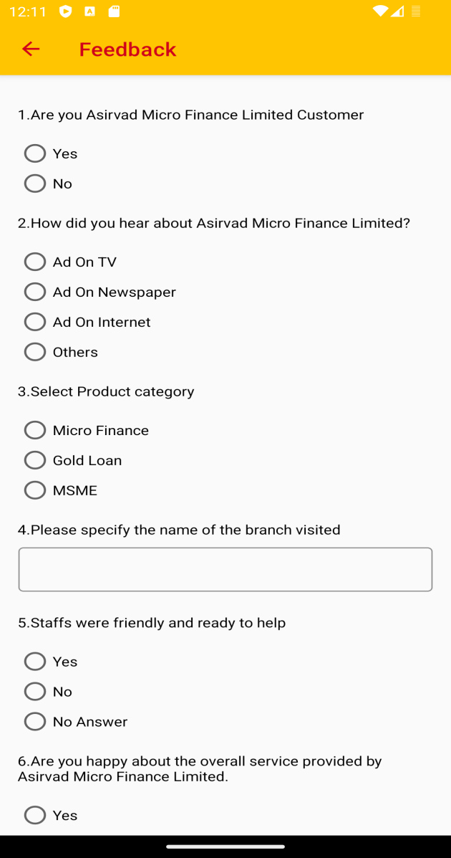
https://apps.asirvad.com/AsirvadGoldloan/OGLLite_MobAppService/Data_Service.asmx/get_feedback

PAN UPDATION

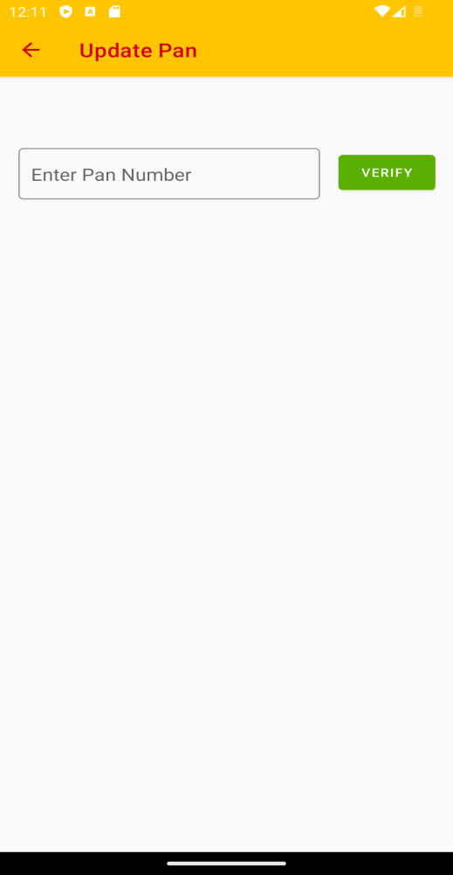

https://apps.asirvad.com/Asirvadgoldloan/mfpublickycapi/api/pan
https://apps.asirvad.com/AsirvadGoldloan/customer_public/api/PAN/updatePan

